**Think Sepsis. Act Fast**

**Background**

Sepsis is a potentially life threatening condition which often presents vaguely; especially early in the course of the illness. Use of a clinical pathway for rapid identification of Sepsis and to initiate appropriate treatment has been shown to save lives, improve patient outcomes and reduce sepsis related health care costs (Thursky et al., 2018). In early 2018, Royal Melbourne hospital (RMH) was granted project funding by Better Care Victoria (BCV) to scale use of the Adult Sepsis Pathway across 11 health services including Bendigo Health. The Sepsis Scaling Collaboration Project, also known as “Think Sepsis. Act Fast” was commenced in April 2018 and completed in March 2019.

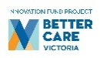 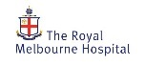    
  
 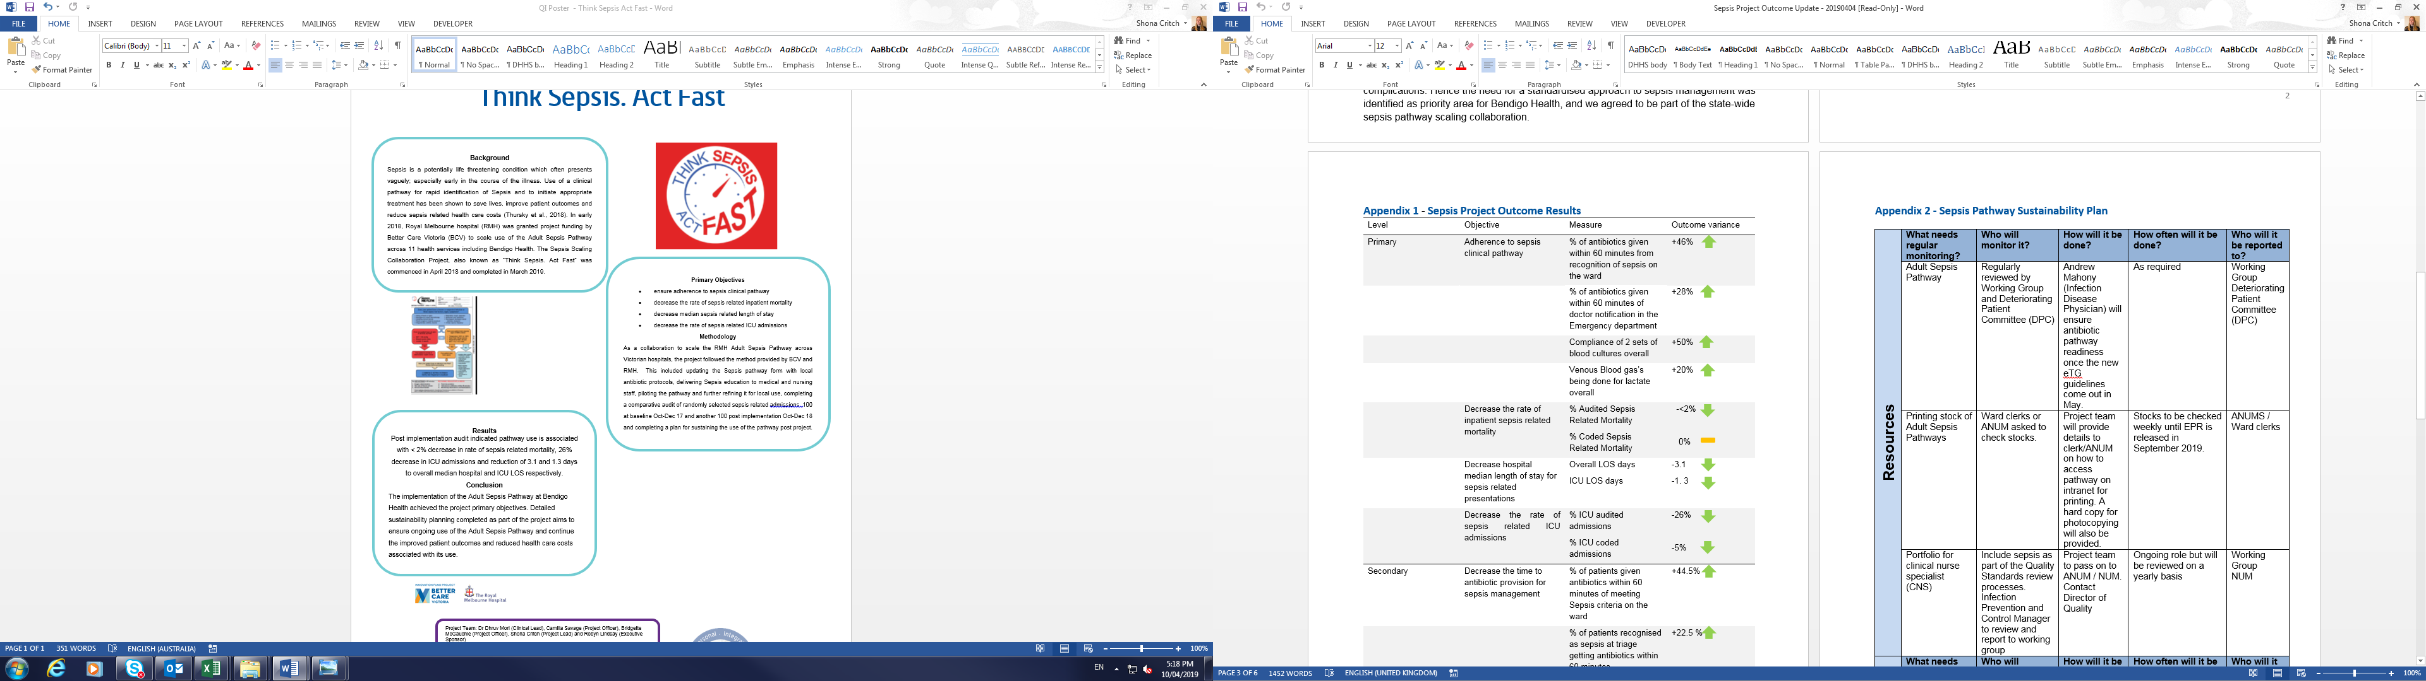

**Primary Objectives**

* ensure adherence to sepsis clinical pathway
* decrease the rate of sepsis related inpatient mortality
* decrease median sepsis related length of stay
* decrease the rate of sepsis related ICU admissions

**Method**

As a collaboration to scale the RMH Adult Sepsis Pathway across Victorian hospitals, the project followed the method provided by BCV and RMH. This included updating the Sepsis pathway form with local antibiotic protocols, delivering Sepsis education to medical and nursing staff, piloting the pathway and further refining it for local use, completing a comparative audit of randomly selected sepsis related admissions; 100 at baseline Oct-Dec 17 and another 100 post implementation Oct-Dec 18 and completing a plan for sustaining the use of the pathway post project.

**Project Team:** Dr Dhruv Mori (Clinical Lead), Camilla Savage (Project Officer), Bridgette McGauchie (Project Officer), Shona Critch (Project Lead) and Robyn Lindsay (Executive Sponsor)

**Date:** April 2019 **Department:** Innovation and Improvement

**Results**

Post implementation audit indicated pathway use is associated with < 2% decrease in rate of sepsis related mortality, 26% decrease in ICU admissions and reduction of 3.1 and 1.3 days to overall median hospital and ICU LOS respectively.

**Conclusion**

The implementation of the Adult Sepsis Pathway at Bendigo Health achieved the project primary objectives. Detailed sustainability planning completed as part of the project aims to ensure ongoing use of the Adult Sepsis Pathway and continue the improved patient outcomes and reduced health care costs associated with its use.